Accessing Coordinator Reports - Table of Contents
Accessing Penn’s Way Coordinator Reports 2
Introduction to Reports: 2
Step 1: Access the Penn’s Way Site 3
Step 2: Where to access the reports? 4
Step 3: Log-in to the Penn’s Way Portal 5
Step 4: Downloading Your Department Reports 6
Select which report you would like to view and open the file 7

Accessing Penn’s Way Coordinator Reports

Introduction to Reports:
Running reports, which illustrate who from your team has participated, is quick and easy.
  - You can use these reports to monitor progress within your department(s) and follow-up with individuals as needed.

This guide will walk you through the report running process step by step.

Please note: you will need your PennKey and Password in order to access the Penn’s Way Pledge Portal. If you do not have that information handy, please click on the Penn Key Online Reset link, which is accessible from the UPHS Intranet page, to reset this information.

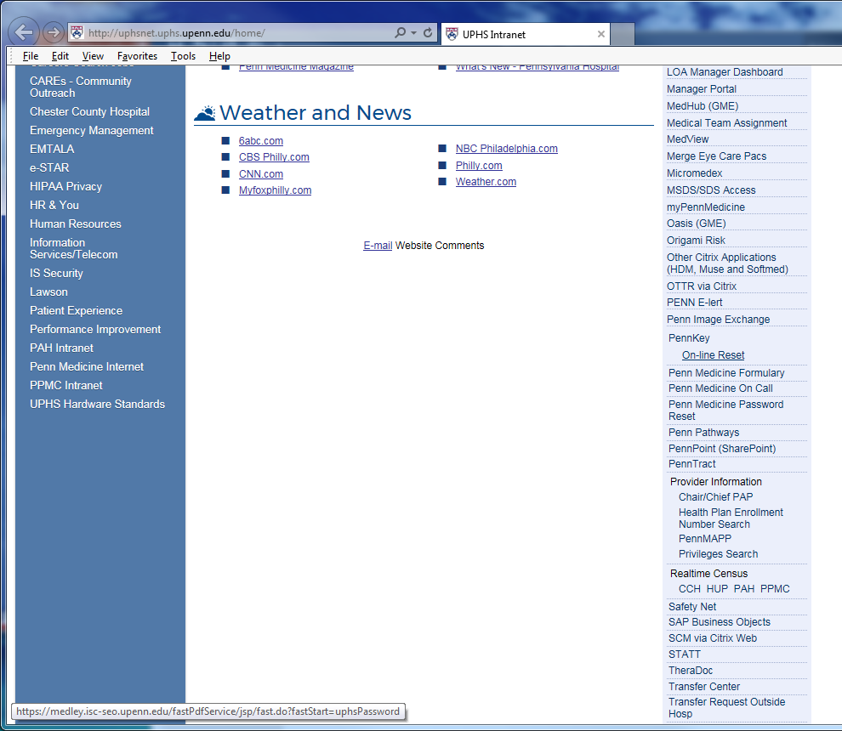

Step 1: Access the Penn’s Way Site
The Penn’s Way site can be accessed by typing in “Penn’s Way” via any internet browser search bar Or by clicking the Penn’s Way Icon under the What’s Hot section on the Penn Medicine Intranet Homepage.
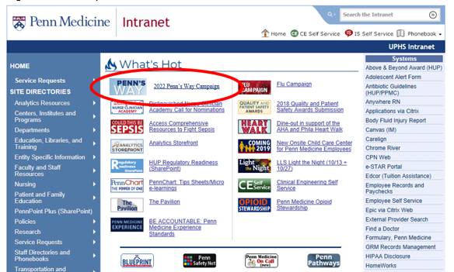

Step 2: Where to access the reports?
Once you access the Penn’s Way site, click the “Donate Now” button just as you would to submit your pledge.
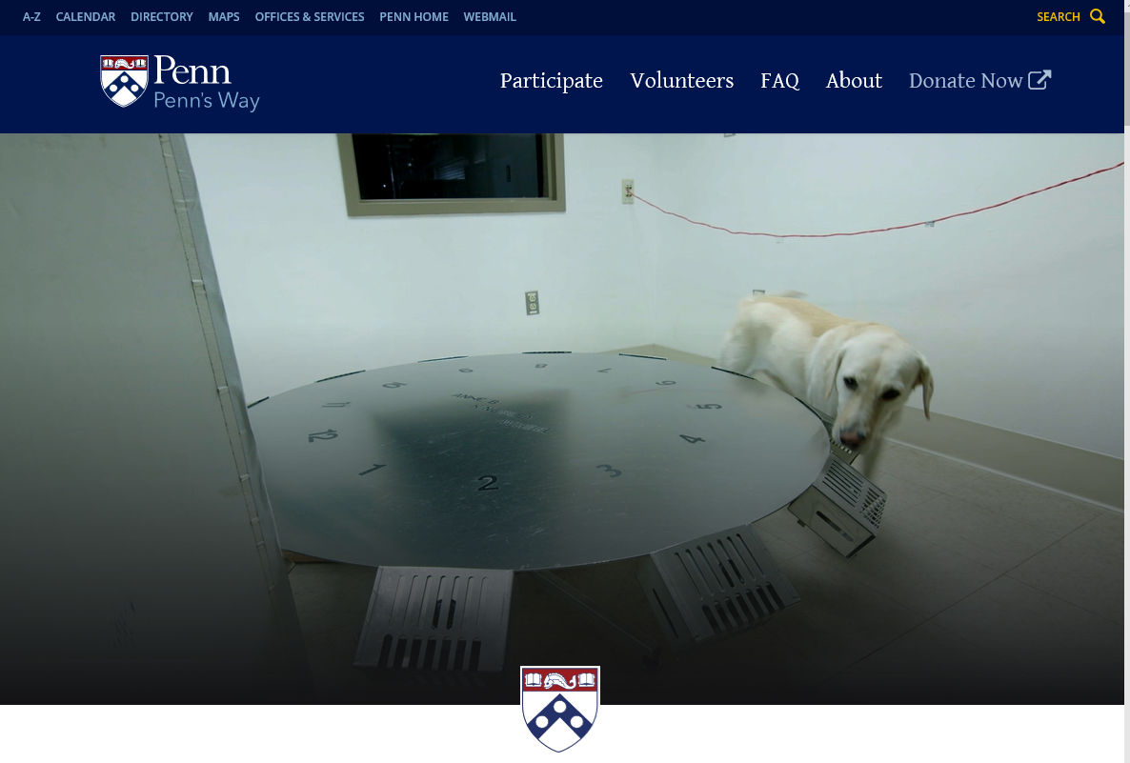

Step 3: Log-in to the Penn’s Way Portal
Simply enter your Penn Key information to gain access to the portal and click “log-in”
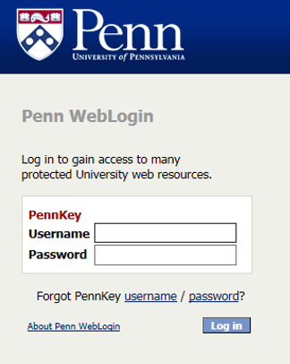

Step 4: Downloading Your Department Reports
Select the “Reports” tab at the top of the page – From here, toggle to “Coordinator Reports”
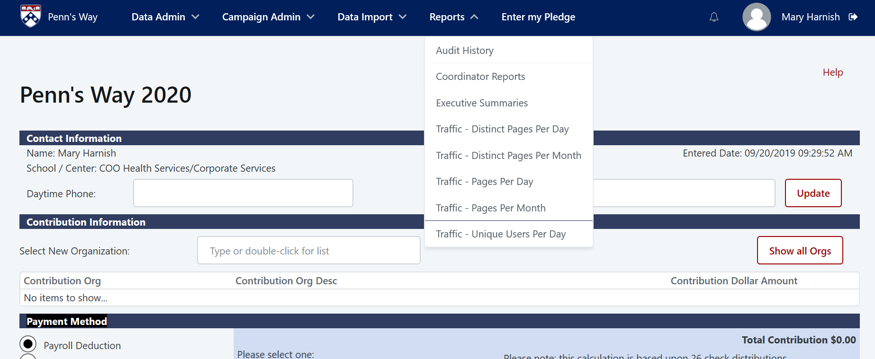
1

Select which report you would like to view and open the file
You can view two different reports
A detail report or a summary report.
  - The Detail reports provide information on individual employee pledges. It does not list the employees pledge amount.
  - An X in the pending payment column indicates a cash/check pledge that needs to be reconciled.
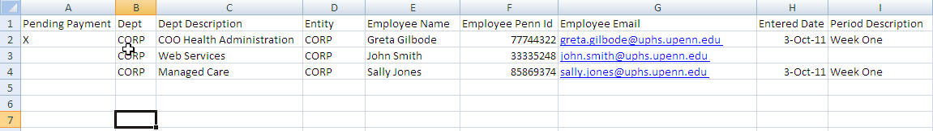
- The Summary reports provides information on a unit, division, or department
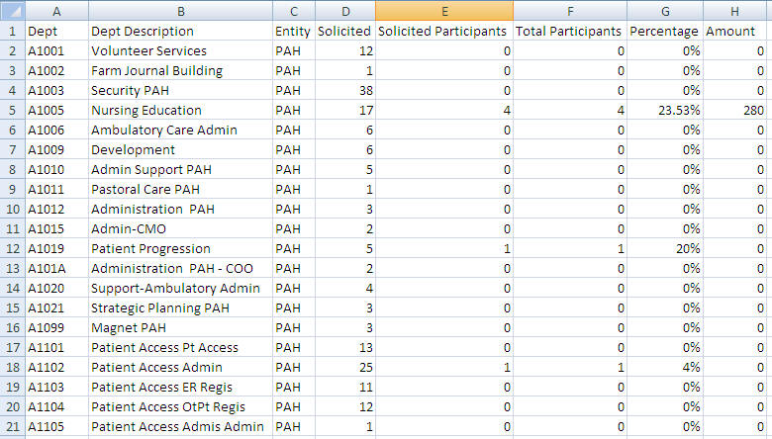
  - Both reports are CSV files that will open up as Excel spreadsheets. If you want to preserve a particular report for a particular date and time, please save these files to your personal drive.
    - Participation only, not dollar amounts
  - These reports are updated real time as employees participate in the campaign; there is no way for you to retrieve a report for a prior date and time unless you have saved the file.
Thank you so much for supporting the campaign! If you have any questions about how to run or work with the coordinator reports please reach out to your Penn’s Way Captain or any of the Campaign Managers

